Name:
Smile Evaluation
Please circle yes or no
- Do you like the way your teeth look? Yes No
Explain-

- Would you like your teeth to be whiter? Yes No
Explain-

- Would you like your teeth to be straighter? Yes No
Explain-
- Do you have spaces between your teeth that you would like to close?
Yes No
Explain-

- Do you like the shape of your teeth? Yes No
Explain-

- Do you like the shape of your teeth? Yes No
Explain-

- Do you have missing teeth that you would like to replace? Yes No
Explain-

- Do you have old silver fillings that you would like to replace with tooth-coloured fillings? Yes No
Explain-

- If you could change anything about your smile, what would it be?

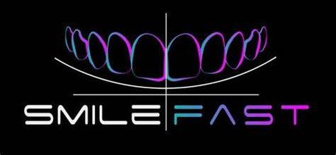
Finance
Free smile consultation!

